We select to use python language because **Python** is an [interpreted](https://en.wikipedia.org/wiki/Interpreted_language), [high-level](https://en.wikipedia.org/wiki/High-level_programming_language) and [general-purpose programming language](https://en.wikipedia.org/wiki/General-purpose_programming_language). Python's design philosophy emphasizes [code readability](https://en.wikipedia.org/wiki/Code_readability) with its notable use of [significant indentation](https://en.wikipedia.org/wiki/Off-side_rule). Its [language constructs](https://en.wikipedia.org/wiki/Language_construct) and [object-oriented](https://en.wikipedia.org/wiki/Object-oriented_programming) approach aim to help [programmers](https://en.wikipedia.org/wiki/Programmers) write clear, logical code for small and large-scale projects.[[29]](https://en.wikipedia.org/wiki/Python_(programming_language)#cite_note-AutoNT-7-29)

Python is [dynamically-typed](https://en.wikipedia.org/wiki/Dynamic_programming_language) and [garbage-collected](https://en.wikipedia.org/wiki/Garbage_collection_(computer_science)). It supports multiple [programming paradigms](https://en.wikipedia.org/wiki/Programming_paradigms), including [structured](https://en.wikipedia.org/wiki/Structured_programming) (particularly, [procedural](https://en.wikipedia.org/wiki/Procedural_programming)), [object-oriented](https://en.wikipedia.org/wiki/Object-oriented_programming) and [functional programming](https://en.wikipedia.org/wiki/Functional_programming). Python is often described as a "batteries included" language due to its comprehensive [standard library](https://en.wikipedia.org/wiki/Standard_library)

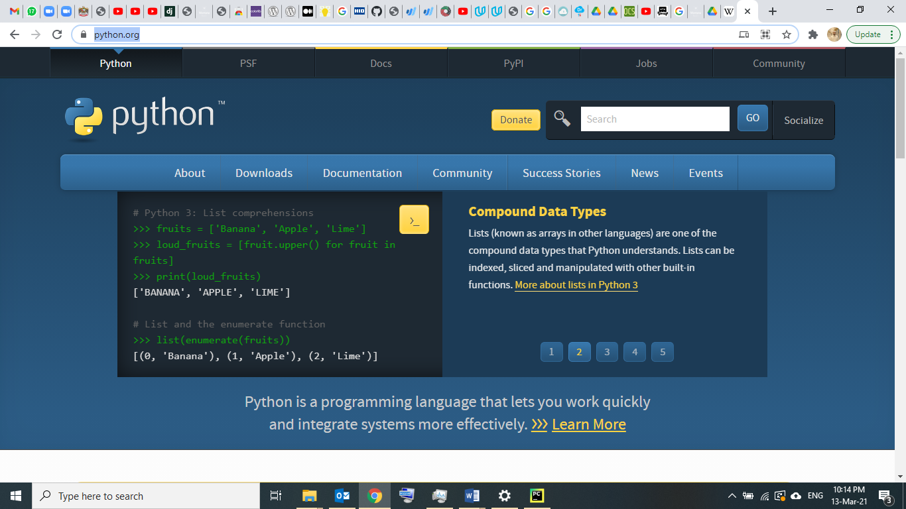

WEB Frame Work

We used Django framework :

Django is a high-level Python Web framework that encourages rapid development and clean, pragmatic design. Built by experienced developers, it takes care of much of the hassle of Web development, so you can focus on writing your app without needing to reinvent the wheel. It’s free and open source.

Ridiculously fast.

Django was designed to help developers take applications from concept to completion as quickly as possible.

Reassuringly secure.

Django takes security seriously and helps developers avoid many common security mistakes.

Exceedingly scalable.

Some of the busiest sites on the Web leverage Django’s ability to quickly and flexibly scale.

**Django** ([/ˈdʒæŋɡoʊ/](https://en.wikipedia.org/wiki/Help:IPA/English) [*JANG-goh*](https://en.wikipedia.org/wiki/Help:Pronunciation_respelling_key); sometimes stylized as **django**)[[8]](https://en.wikipedia.org/wiki/Django_(web_framework)#cite_note-8) is a [Python](https://en.wikipedia.org/wiki/Python_(programming_language))-based [free and open-source](https://en.wikipedia.org/wiki/Free_and_open-source_software) [web framework](https://en.wikipedia.org/wiki/Web_framework) that follows the model-template-views (MTV) [architectural pattern](https://en.wikipedia.org/wiki/Architectural_pattern_(computer_science)).[[9]](https://en.wikipedia.org/wiki/Django_(web_framework)#cite_note-faq-mvc-9)[[10]](https://en.wikipedia.org/wiki/Django_(web_framework)#cite_note-djangobook-mvc-10) It is maintained by the [Django Software Foundation](https://en.wikipedia.org/wiki/Django_Software_Foundation) (DSF), an American independent organization established as a [501(c)(3)](https://en.wikipedia.org/wiki/501(c)(3)) non-profit.

Django's primary goal is to ease the creation of complex, database-driven websites. The framework emphasizes [reusability](https://en.wikipedia.org/wiki/Reusability) and "pluggability" of components, less code, low coupling, rapid development, and the principle of [don't repeat yourself](https://en.wikipedia.org/wiki/Don%27t_repeat_yourself).[[11]](https://en.wikipedia.org/wiki/Django_(web_framework)#cite_note-11) Python is used throughout, even for settings, files, and data models. Django also provides an optional administrative [create, read, update and delete](https://en.wikipedia.org/wiki/Create,_read,_update_and_delete) interface that is generated dynamically through [introspection](https://en.wikipedia.org/wiki/Type_introspection) and configured via admin models.

Some well known sites that use Django include [PBS](https://en.wikipedia.org/wiki/PBS),[[12]](https://en.wikipedia.org/wiki/Django_(web_framework)#cite_note-20sites-12) [Instagram](https://en.wikipedia.org/wiki/Instagram),[[13]](https://en.wikipedia.org/wiki/Django_(web_framework)#cite_note-13) [Mozilla](https://en.wikipedia.org/wiki/Mozilla_Foundation),[[14]](https://en.wikipedia.org/wiki/Django_(web_framework)#cite_note-14) [*The Washington Times*](https://en.wikipedia.org/wiki/The_Washington_Times),[[15]](https://en.wikipedia.org/wiki/Django_(web_framework)#cite_note-15) [Disqus](https://en.wikipedia.org/wiki/Disqus" \o "Disqus),[[16]](https://en.wikipedia.org/wiki/Django_(web_framework)#cite_note-16) [Bitbucket](https://en.wikipedia.org/wiki/Bitbucket" \o "Bitbucket),[[17]](https://en.wikipedia.org/wiki/Django_(web_framework)#cite_note-17) and [Nextdoor](https://en.wikipedia.org/wiki/Nextdoor" \o "Nextdoor).[[18]](https://en.wikipedia.org/wiki/Django_(web_framework)#cite_note-18)

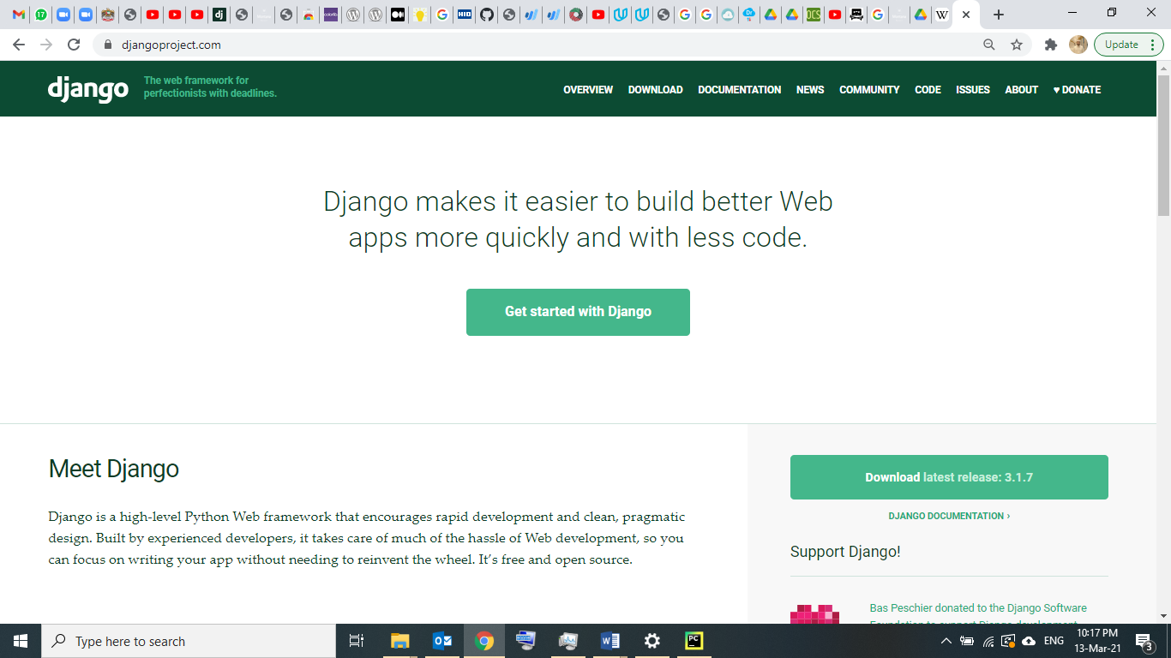

Development Environment : PYCHARM

**PyCharm** is an [integrated development environment](https://en.wikipedia.org/wiki/Integrated_development_environment) (IDE) used in [computer programming](https://en.wikipedia.org/wiki/Computer_programming), specifically for the [Python](https://en.wikipedia.org/wiki/Python_(programming_language)) language. It is developed by the [Czech](https://en.wikipedia.org/wiki/Czech_Republic) company [JetBrains](https://en.wikipedia.org/wiki/JetBrains" \o "JetBrains).[[5]](https://en.wikipedia.org/wiki/PyCharm#cite_note-5) It provides code analysis, a graphical debugger, an integrated unit tester, integration with [version control systems](https://en.wikipedia.org/wiki/Revision_control) (VCSes), and supports web development with [Django](https://en.wikipedia.org/wiki/Django_(web_framework)) as well as [data science](https://en.wikipedia.org/wiki/Data_science) with [Anaconda](https://en.wikipedia.org/wiki/Anaconda_(Python_distribution)).[[6]](https://en.wikipedia.org/wiki/PyCharm#cite_note-6)

PyCharm is [cross-platform](https://en.wikipedia.org/wiki/Cross-platform), with [Windows](https://en.wikipedia.org/wiki/Windows), [macOS](https://en.wikipedia.org/wiki/MacOS" \o "MacOS) and [Linux](https://en.wikipedia.org/wiki/Linux) versions. The Community Edition is released under the [Apache License](https://en.wikipedia.org/wiki/Apache_License),[[7]](https://en.wikipedia.org/wiki/PyCharm#cite_note-community-7) and there is also Professional Edition with extra features – released under a [proprietary license](https://en.wikipedia.org/wiki/Proprietary_software).

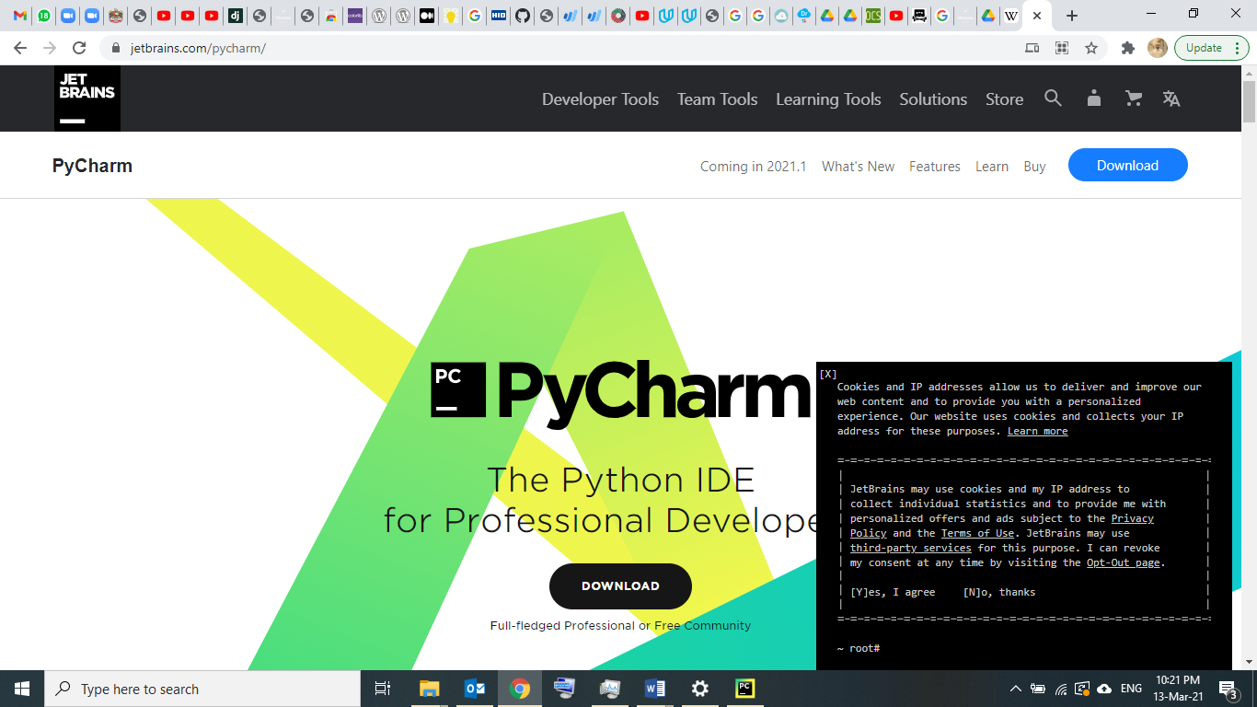

How the Django web project works

In a traditional data-driven website, a web application waits for HTTP requests from the web browser (or other client). When a request is received the application works out what is needed based on the URL and possibly information in POST data or GET data. Depending on what is required it may then read or write information from a database or perform other tasks required to satisfy the request. The application will then return a response to the web browser, often dynamically creating an HTML page for the browser to display by inserting the retrieved data into placeholders in an HTML template.

Django web applications typically group the code that handles each of these steps into separate files:

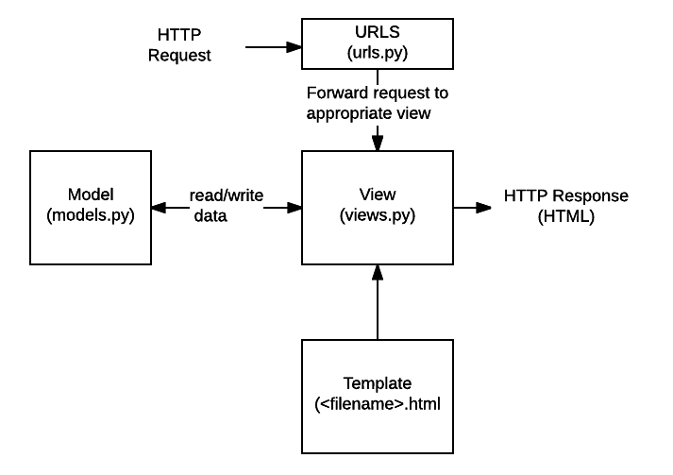

* **URLs:**While it is possible to process requests from every single URL via a single function, it is much more maintainable to write a separate view function to handle each resource. A URL mapper is used to redirect HTTP requests to the appropriate view based on the request URL. The URL mapper can also match

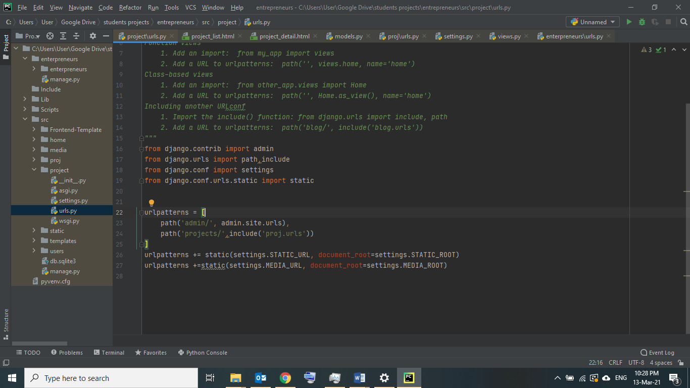

particular patterns of strings or digits that appear in a URL and pass these to a view function as data.

* **View:** A view is a request handler function, which receives HTTP requests and returns HTTP responses. Views access the data needed to satisfy requests via *models*, and delegate the formatting of the response to *templates*.

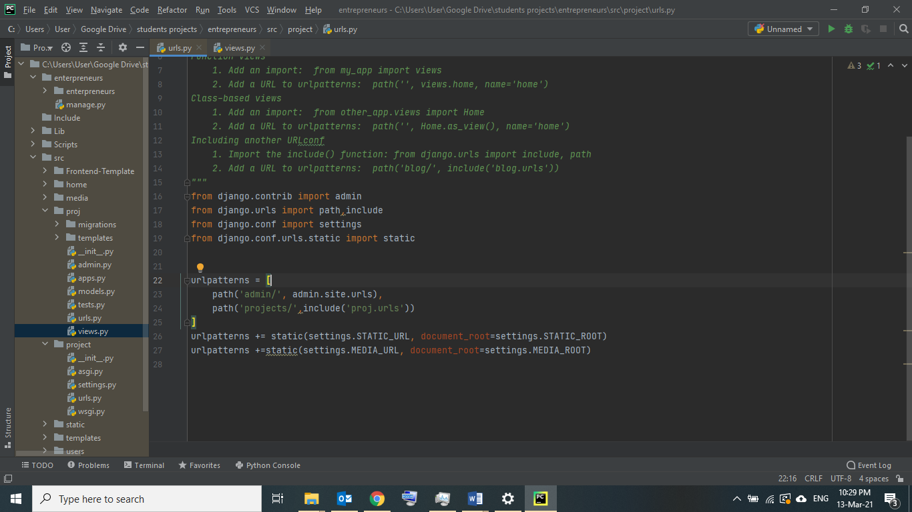

* **Models:** Models are Python objects that define the structure of an application's data, and provide mechanisms to manage (add, modify, delete) and query records in the database.

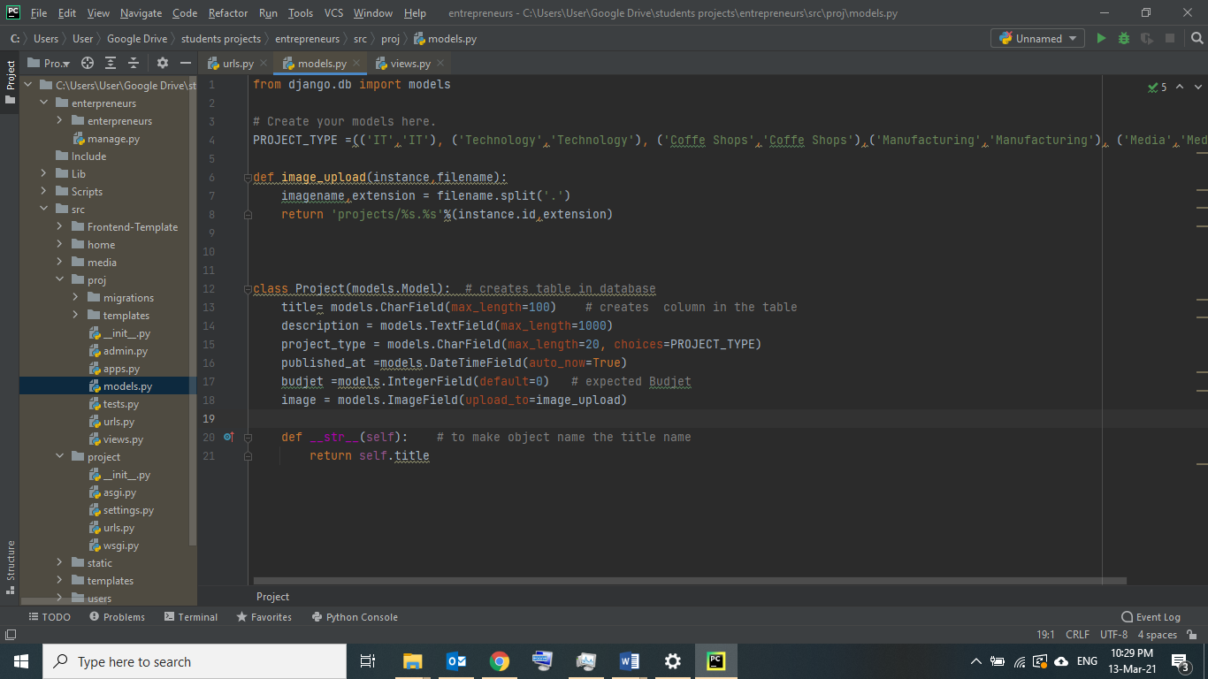

* **Templates:** A template is a text file defining the structure or layout of a file (such as an HTML page), with placeholders used to represent actual content. A *view* can dynamically create an HTML page using an HTML template, populating it with data from a *model*. A template can be used to define the structure of any type of file; it doesn't have to be HTML!

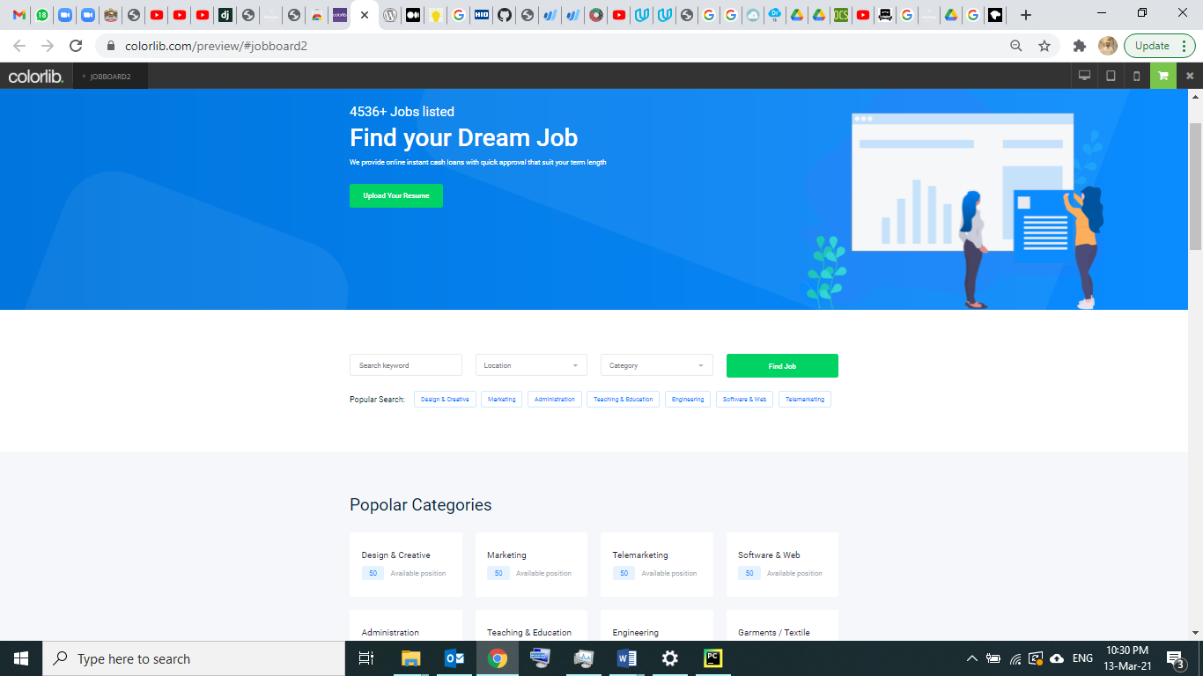

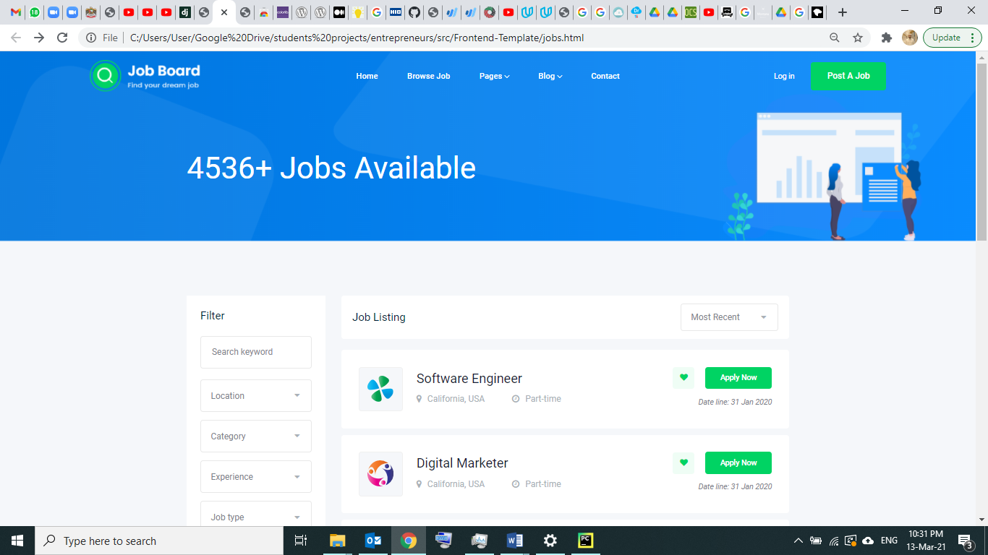

references :

<https://en.wikipedia.org/wiki/Python_(programming_language)>

<https://www.python.org/>

<https://en.wikipedia.org/wiki/Django_(web_framework)>

<https://www.djangoproject.com/>

https://docs.djangoproject.com/en/3.1/intro/overview/

<https://en.wikipedia.org/wiki/PyCharm>

<https://www.jetbrains.com/pycharm/>

https://www.w3schools.com/html/